Webpage: Looking for an alternative to MBTI?

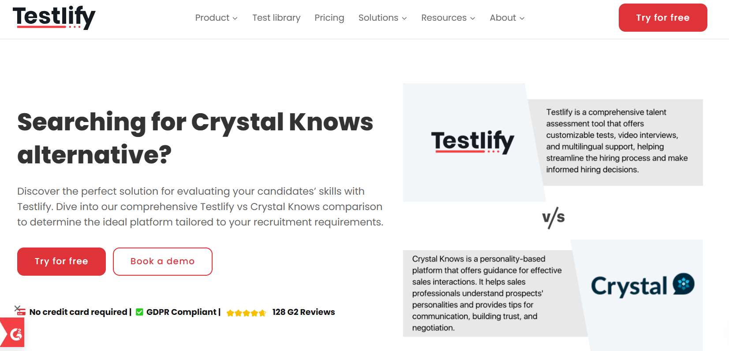
Insert Book a call and download a sample profile CTAs in hero

Copy for this hero image:
C-me:
C-me offers one of the most personalised and cost-effective approaches to personal, team and organisational development in the learning and development space. We have shifted the focus of workplace psychometric tools from fixed ‘personality types’ to a more useful focus on ‘adaptable behaviours’. C-me is designed for practical application in busy working environments.
MBTI:
​DISC is a profiling system the categorizes individuals into 16 personality types. MBTI is more focussed on personal exploration - helping people understand their preferences in how they perceive the world and make decisions. It is a much more rigid tool and not as effective in the workplace.

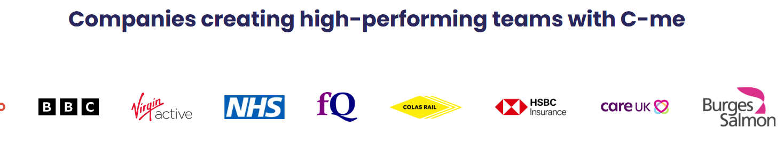

Why look for a MBTI alternative?

Performance. User experience.
MBTI is a much more rigid tool, focussing on fixed ‘personality types’. It boxes users in to one fixed category. It is more complex to remember and there, not as applicable in the workplace.
C-me was designed to more accurately reflect people’s behaviour in the workplace and how they change and develop. It is a more modern, powerful but simpler tool, which is more reflective of actual human behaviour. It is also easier to adopt and remember, therefore more effective in the workplace.

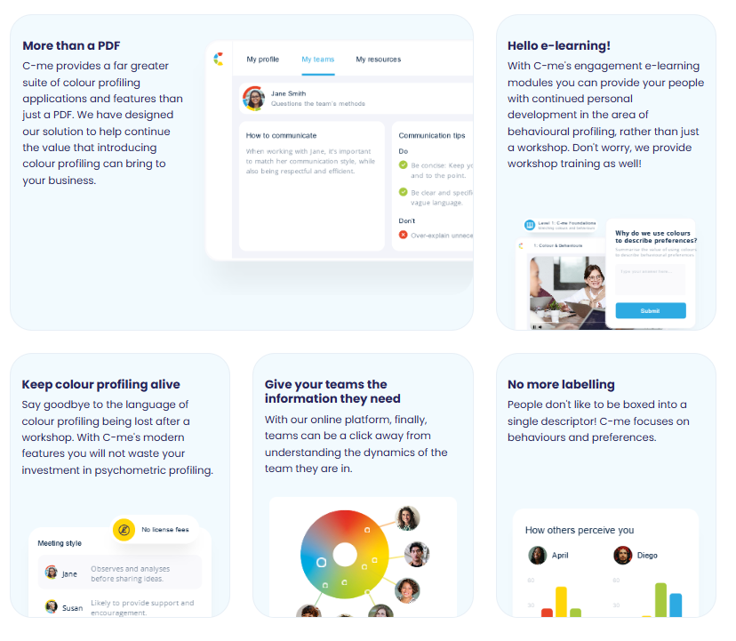
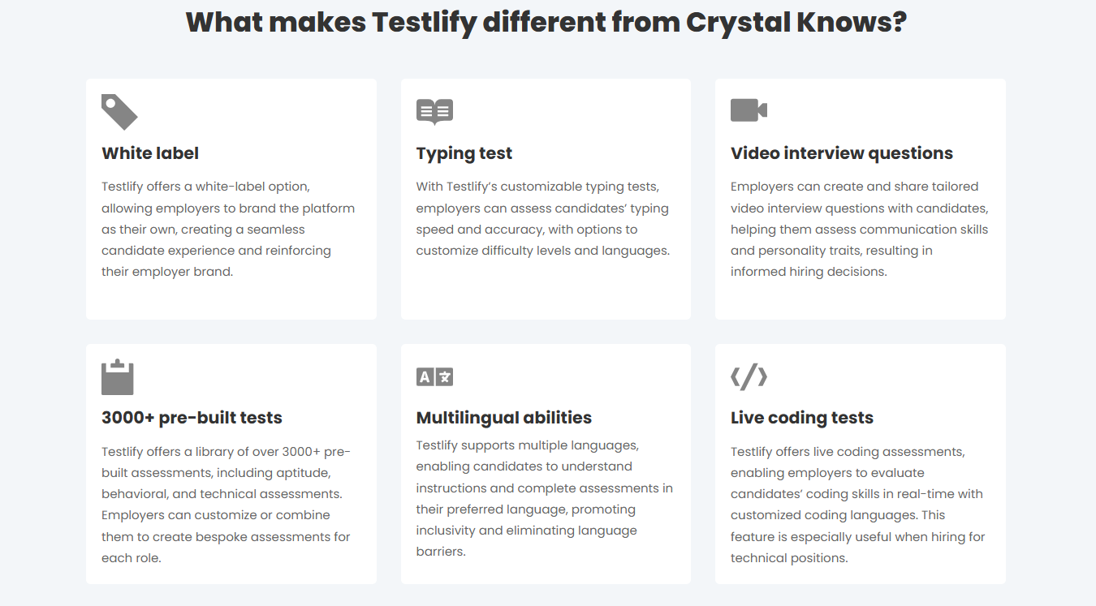

Please turn these points in to something that looks like the above graphics

What makes C-me different from MBTI?

- No more labelling – No one likes to be boxed into a single descriptor. We are more complex and organisations need a tool to more accurately reflect how we change and develop at work. C-me focuses on how a person’s behaviours and preferences flex in different circumstances. We reveal when this might happen and how to plan for it.
- Behaviour not personality – we have changed the focus from personality to behaviour. Our personality remains pretty fixed in our life time, where as our behaviour can and should change as we develop. Crucially, our behaviour is what others observe about us. It is much more empowering to focus on what individuals can change than asking them to change their personality.
- Faster to learn and more memorable – There is no need to master a complex system of letters in order to remember your own profile and even those of everyone you’re working with. C-me simpler focus on four colours can bring teams together from day one in any industry and context, because it’s designed to be faster to learn and effective immediately.
- Take charge of how you use C-me - Add your brand on the assessment, on the report, on the platform, on the workshop material. Take the C-me material and integrate it into your existing tools. We provide the tools for you to make it work for you.
- A more user-friendly, interactive platform for all C-me activity - view your report, tailor it, share it, and view the team wheels you’re a part of, work through coaching questions, and prepare for meetings by viewing the reports of anyone in your organisation. Access our e-Learning tool and app add-ins. One place to access C-me.

Client quote
After 15 years working with other psychometric tools, C-me offer such a refreshing and much more applicable profile focused on adapted behaviour rather than defining a type.

Paul McGowran,Managing Director, Seek First Ltd

How C-me and MBTI compare

MBTI

The MBTI framework identifies four key dimensions of personality, each represented as a pair of opposite preferences:
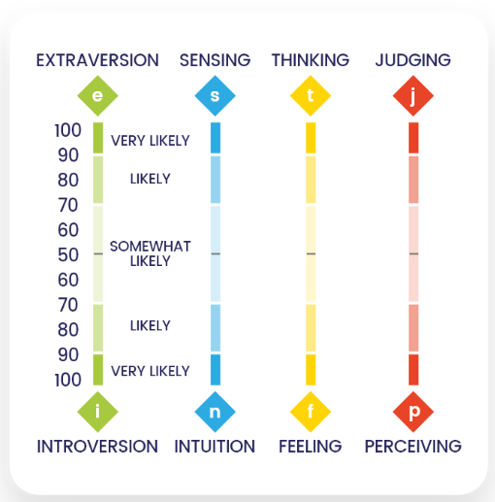

These four preference pairs combine to create 16 distinct personality types. Each individual has a preference from each pair, resulting in a unique four-letter code.
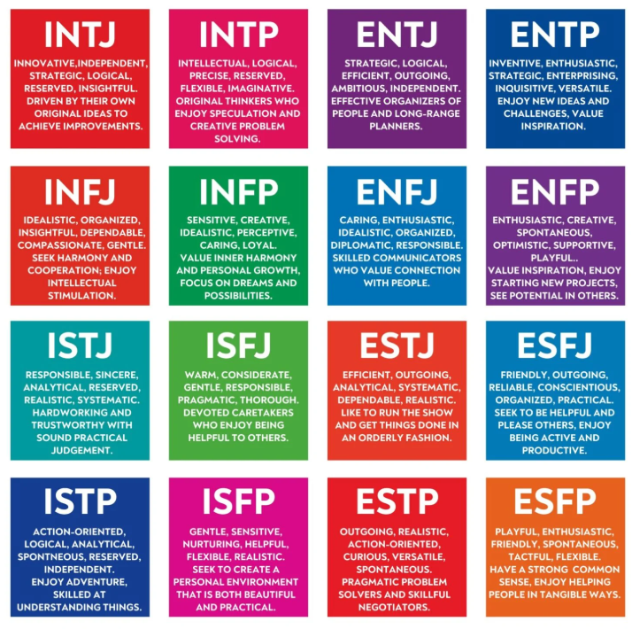

Here are some examples of how MBTI represent a person’s profile. There are many different supplieres who present it in various ways.
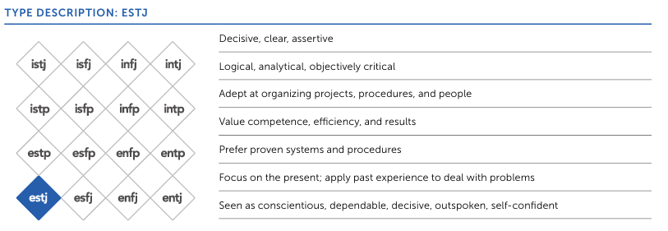

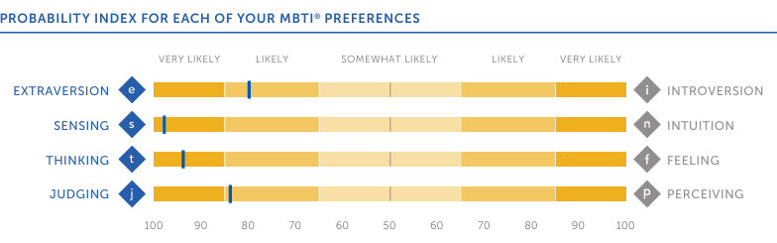
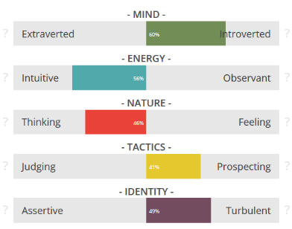

C-me

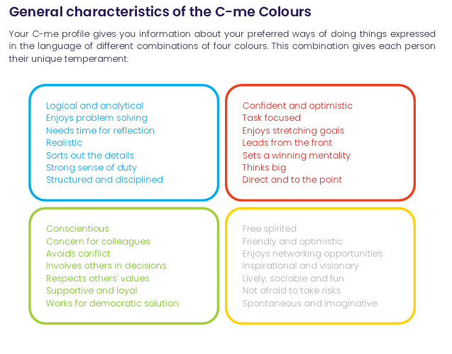

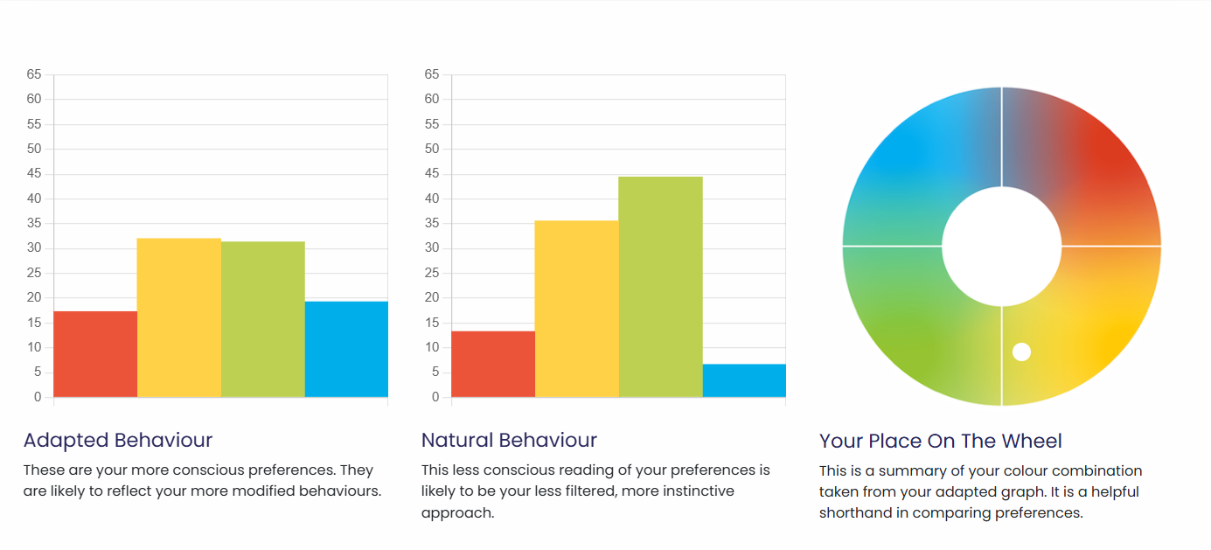

C-me's dynamic approach, represented by a blended colour wheel, offers a nuanced description of individual profiles. Unlike MBTI's predefined typology, C-me's algorithms emphasise behavioural nuances. We make room for change – indicated by a wheel that people can move around and two graphs that reflected how people change in the workplace, depending on the circumstances.
We avoid letters categorise people. Instead we use a blended colour wheel. This visually communicates the fact that people are a blend of all the preferences. Behaviour changes and people can move around the wheel in different roles.
We don’t ask responders to remember a combination of letters, we simply encourage people to learn the four colours of the colour wheel and what they stand for. We ask that users to remember their top two preferred colours -not one but two, again to emphasise that people are a blend. A person’s profile is not stuck to one inflexible category. We do not box people in. We encourage flexibility and growth. This emphasises that none of us are one static category, we flex between colours depending on the circumstances we’re in.

What are the similarities:
- Both are based on Jungian psychology.
- Both use preference indicators​ in the questionnaire – i.e. we ask people to rate themselves and their own preference.

CTA: Take a 3 min tour of C-me

Client testimonial
“Getting busy people working in a client driven commercial environment to free up time for their CPD is pivotal, and where C-Me is worth its weight is in how accessible and colloquial it is. It allows us to use it as a shared language (and subsequent understanding) to improving collaboration by understanding each other's preferences.” Gavin XXX from Burgess Salmon

Client testimonies of C-me’s accreditation

I would definitely recommend the accreditation. It was delivered in a clear, concise and friendly way that was easy to understand. There was room for discussion and time to reflect which was really valuable.- Claudia Shaw- The Kings Trust
Fun, easy to understand, flexible/ adaptable tool to many purposes, inclusive approach- Stephanie Lascaud- Q5
We have developed a short, intensive accreditation, spread over two successive half-days. It’s designed to be fun and accessible. To get you and your team up to speed, fast.

Where C-me delivers impact
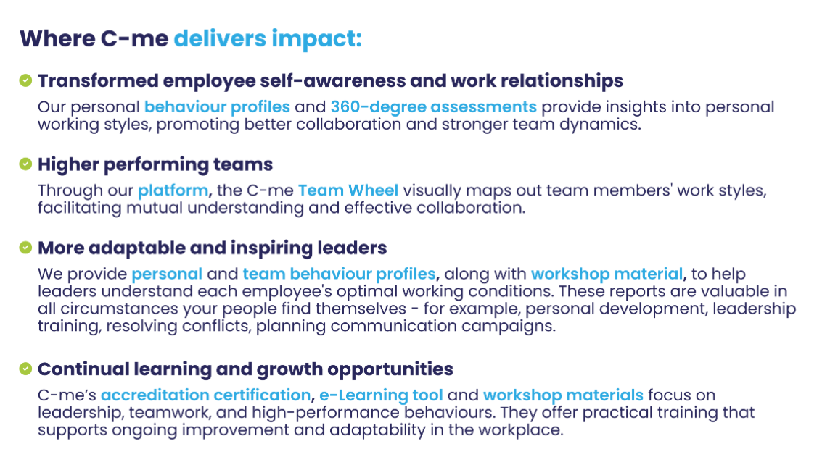
Could you create a more attractive visual of this with icons please?

FAQs
- How is your assessment validated?
Download our validation report here.
- What is your pricing?
Contact our Sales Team to discuss our pricing for your business.
- How quickly can we roll out C-me in our organisation?
We will work hard to fit to your timelines. The quickest option is for you to bring in a qualified C-me consultant. Please see our Solution Partner Directory for our trusted partners (insert link). You can also choose to gain a qualification and get yourself and your team accredited to deliver C-me in your organisation: we run accreditation courses every 4-6 weeks (taking place over two successive days). On completion of the course, you can roll out C-me immediately.
- Can I view a sample report?
Yes, of course, download one here: insert link.

Why people love C-me

Include testimony matrix

Whether you’re a global brand, Fortune 500 organisation, nonprofit, or startup, C-me is tailored to fit teams of any size.
If you would like to discuss how we can help your business, book a call with us.

CTA: Book a call

Please include a carousel with links to all other competitor pages

