Webpage: Looking for an alternative to Belbin

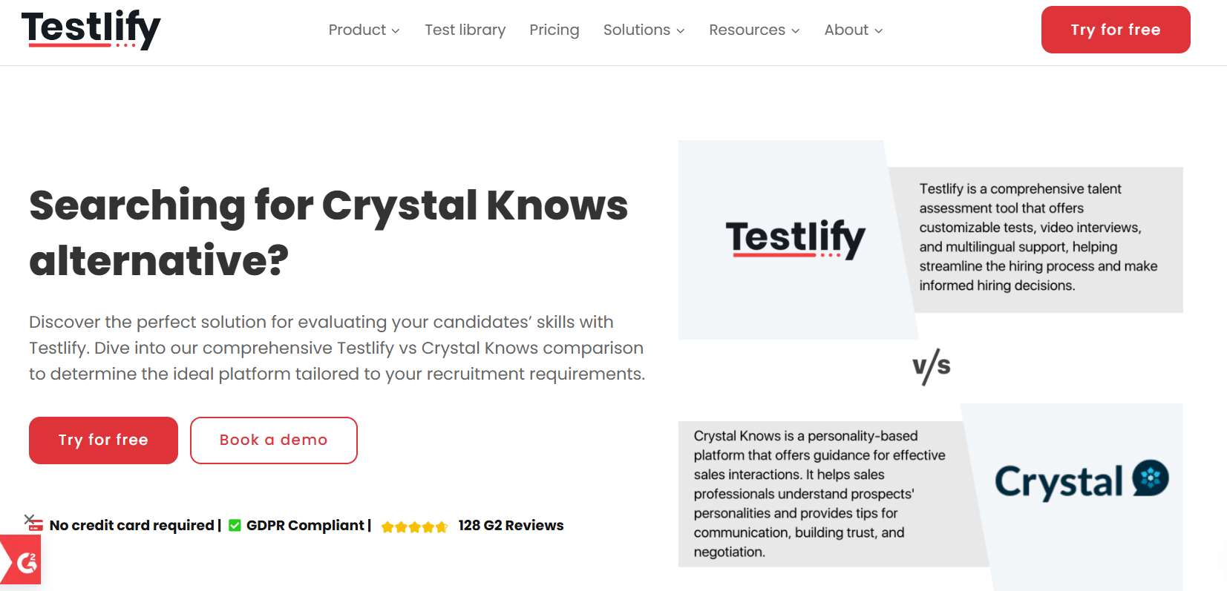
Insert Book a call and download a sample profile CTAs in hero

Copy for this hero image:
C-me: C-me offers one of the most user-friendly and cost-effective approaches to personal, team and organisational development in the learning and development space. C-me is designed for practical application in busy working environments.
Belbin: ​ Belbin is best suited for identifying behavioural strengths and weaknesses within teams by categorising individuals into nine distinct team roles. Their approach focuses on assembling balanced teams, improving collaboration, and overall team performance by ensuring that all necessary roles are represented. It specifically focuses on team alone.

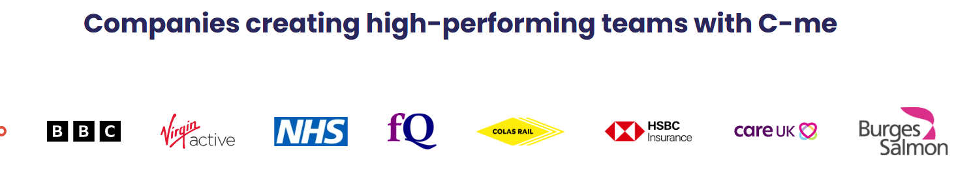

Why look for a Belbin alternative?

Purpose.
Belbin is primarily used for team composition and understanding team dynamics. C-me, however, has a wider bredth of application - spanning personal growth, team synergy, leadership development, and nurturing a thriving organisational culture.

[Client testimony]

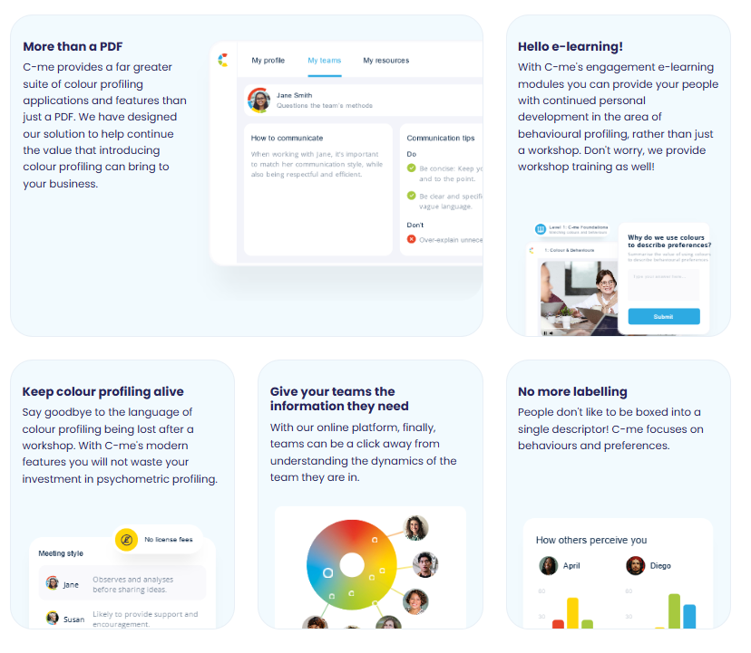
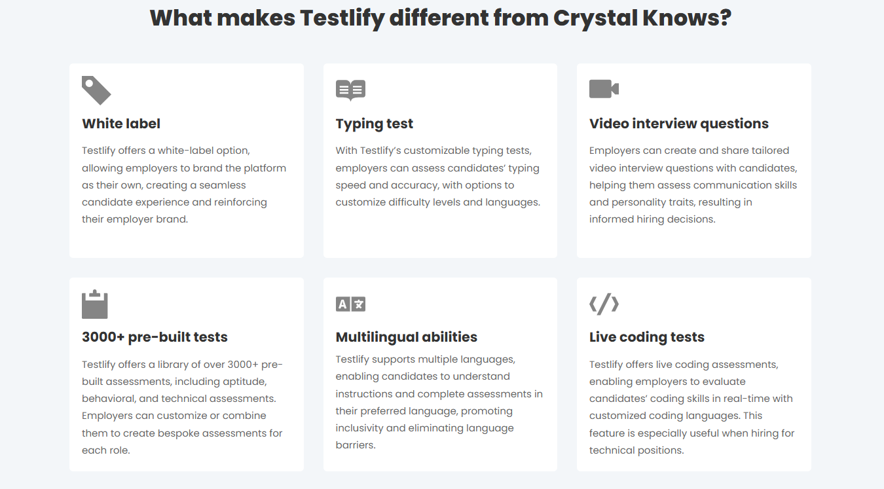

Please turn these points in to something that looks like the above graphics

What makes C-me different from Belbin?

- Faster to learn and more memorable – There is no need to master a complex system in order to remember your own profile and even those of everyone you’re working with. C-me can bring teams together from day one in any industry and context, because it’s designed to be faster to learn and effective immediately.
- Keep things simple – Our colour-coded profiles provide an intuitive and easily digestible visual representation of behavioural styles. We avoid text heavy reports with multiple endless graphs. We offer a more fluid and blended understanding of individual styles.
- Flexibility – C-me profiles are designed to be dynamic, reflecting changes over time and in different contexts. Making us more suitable for personal and leadership growth. Belbin roles tend to be more static, focusing on consistent behavioural contributions within teams.
- Take charge of how you use C-me - Add your brand on the assessment, on the report, on the platform, on the workshop material. Take the C-me material and integrate it into your existing tools. We provide the tools for you to make it work for you.
- A more user-friendly, interactive platform for all C-me activity - view your report, tailor it, share it, and view the team wheels you’re a part of, work through coaching questions, and prepare for meetings by viewing the reports of anyone in your organisation. Access our e-Learning tool and app add-ins. One place to access C-me.
- Jargon free statements – We use more updated language and so that our reports speak directly to the user. You can even select your preferred pronoun.

How C-me and Belbins’ psychometric tools compare

Samples of how Belbin represent a person’s profile visually:

Download a sample report: Belbin Individual Team Role Report

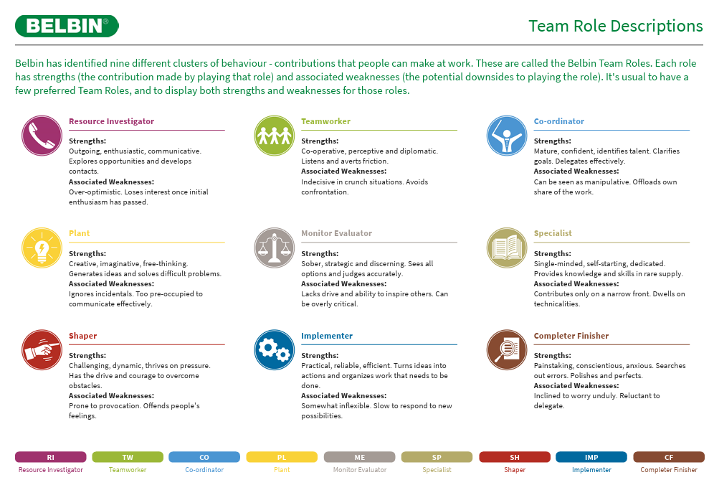

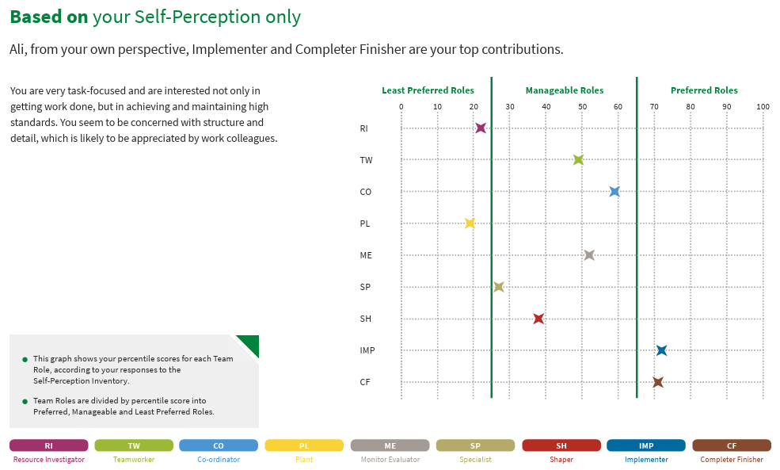

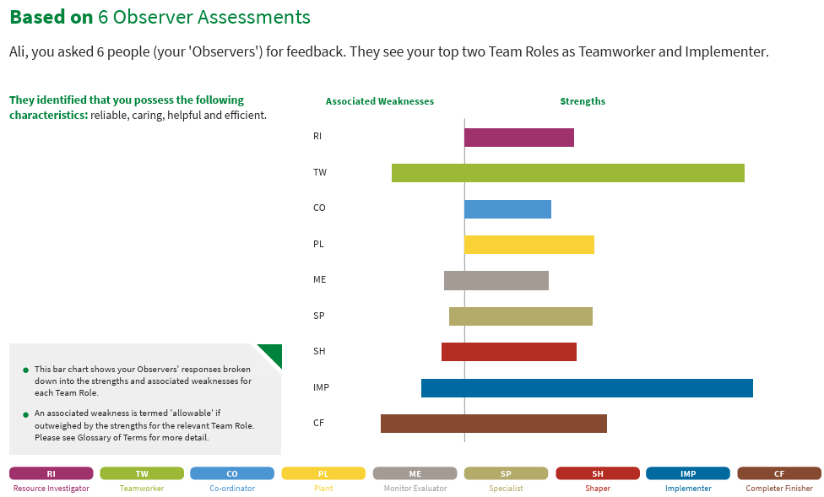
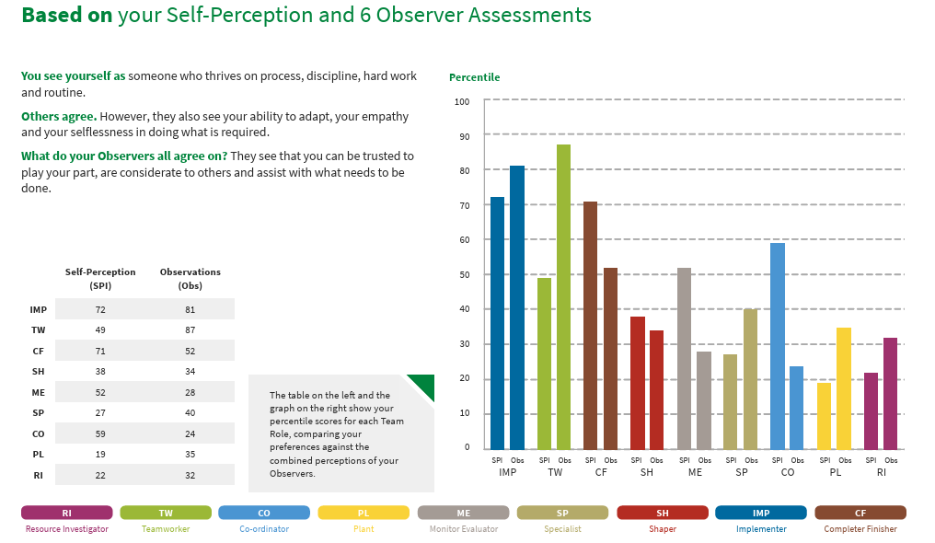

Belbin team profile:
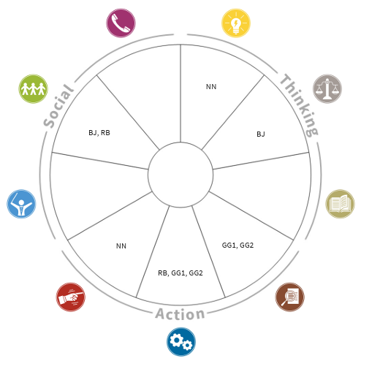

How C-me represent a person’s profile visually:

Download a sample report: C-me Sample Report

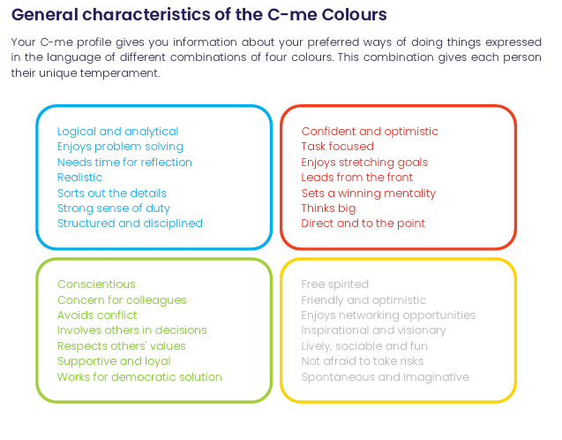
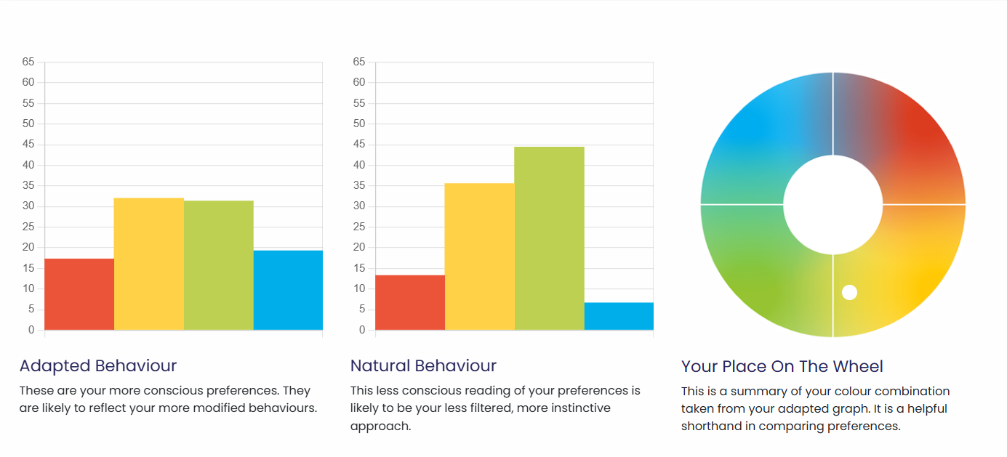
C-me tam profile:
Insert sample team wheel

What are the similarities:
- Focus on behaviour: Both tools assess behavioural tendencies
- Both use preference indicators​ – i.e. we ask people to rate themselves and their own preference.
- Team Development – both aim to improve team performance by increasing understanding of individual contributions and interpersonal dynamics.
- Actionable Insights: Both provide practical recommendations to enhance collaboration and efficiency within teams.

What are the differences:

It’s simple really. C-me represent data more simply.
Our tool is based around four colours that represent four categories of behaviours. We have colour coded behaviours to make it much simpler to remember and translate into any environment.
We present only two bar graphs, instead of multiple iterations of the data.
You’ll notice within our wheel that colours are blended, without rigid divisions or numbers. We stripped off numbers, letters or strict categories to reflect that we are each a combination of all four colours. We don’t ask responders to remember numbers and their according categories. Instead, we simply encourage people to learn the four colours of the wheel and what they stand for. We ask that users simply remember their top two preferred colours. A person’s profile is not stuck to one inflexible category. We do not box people in. We encourage flexibility and growth. This emphasises that none of us are one static category, we flex between colours depending on the circumstances we’re in.
We also provide a simple C visual, that displays the colour order of a person’s preferences, as memorable icon to display and show others their colour preferences simply:

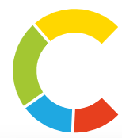

CTA: Take a 3 min tour of C-me

Client testimonial
“Getting busy people working in a client driven commercial environment to free up time for their CPD is pivotal, and where C-Me is worth its weight is in how accessible and colloquial it is. It allows us to use it as a shared language (and subsequent understanding) to improving collaboration by understanding each other's preferences.” Gavin XXX from Burgess Salmon

Client testimonies of C-me’s accreditation

I would definitely recommend the accreditation. It was delivered in a clear, concise and friendly way that was easy to understand. There was room for discussion and time to reflect which was really valuable.- Claudia Shaw- The Kings Trust
Fun, easy to understand, flexible/ adaptable tool to many purposes, inclusive approach- Stephanie Lascaud- Q5
We have developed a short, intensive accreditation, spread over two successive half-days. It’s designed to be fun and accessible. To get you and your team up to speed, fast.

Where C-me delivers impact
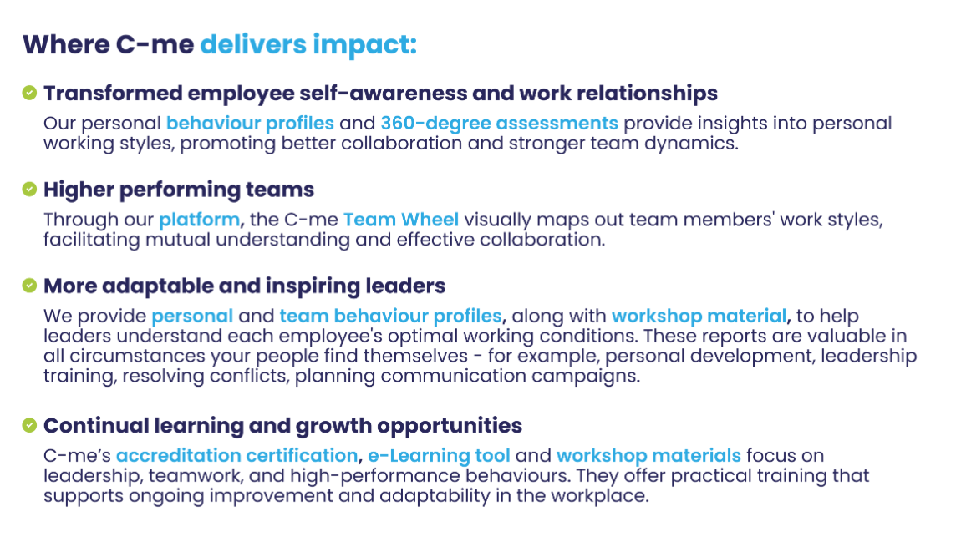
Could you create a more attractive visual of this with icons please?

FAQs
- How is your assessment validated?
Download our validation report here.
- What is your pricing?
Contact our Sales Team to discuss our pricing for your business.
- How quickly can we roll out C-me in our organisation?
We will work hard to fit to your timelines. The quickest option is for you to bring in a qualified C-me consultant. Please see our Solution Partner Directory for our trusted partners (insert link). You can also choose to gain a qualification and get yourself and your team accredited to deliver C-me in your organisation: we run accreditation courses every 4-6 weeks (taking place over two successive days). On completion of the course, you can roll out C-me immediately.
- Can I view a sample report?
Yes, of course, download one here: insert link.

Why people love C-me

Include testimony matrix

Whether you’re a global brand, Fortune 500 organisation, nonprofit, or startup, C-me is tailored to fit teams of any size.
If you would like to discuss how we can help your business, book a call with us.

CTA: Book a call

Please include a carousel with links to all other competitor pages

